=]=[]\]

**A PROJECT REPORT ON**

## **Age and Gender Detection Using Machine Learning**

**SUBMITTED BY**

Ms. Jinal Gujar - 4802

Ms. Aanchal Yadav- 4828

**2023-2024**

**UNDER THE GUIDANCE OF**

Mr. Mithilesh V

**SUBMITTED IN PARTIAL FULFILMENT OF THE REQUIREMENTS FOR QUALIFYING M.Sc. (I.T), SEMESTER-II EXAMINATION.**



**Thakur College of science & commerce,**

**Shyamnarayan Thakur Marg, Thakur Village, Kandivali (E),**

**Mumbai – 400101.**

**CERTIFICATE OF APPROVAL**

This is to certify that **Ms. Jinal Gujar** **and Ms. Aanchal Yadav** of “Master of Science (Information Technology)” of “Thakur College of Science and Commerce.” **Roll No. 4802** **and 4828**  have completed and submitted the Project work & Assignment entitled “**AGE AND GENDER DETECTION USING MACHINE LEARNING**” in the partial fulfillment as per the syllabus defined by the University of Mumbai in the academic year 2024-2025.

It is further certified that the student has completed all the required phases of the practical & assignment.

**__________________________**

**HEAD OF DEPARTMENT**

**_________________________ ________________________**

**PROFESSOR IN CHARGE EXTERNAL EXAMINER**

# PREFACE

Many students state that writing a thesis is like a journey. In our case, this is surely true. This has been a long journey both in time and space. Our interest in image processing evolved when we started reading books, and blogs and attending seminars related to image processing. This interest finally landed us on a project related to image processing whose prime motto is to classify Satellite Images and to help for the betterment of the environment.

Huge thanks to our project guide Mr. Mithilesh V. You were always there when we needed help, regardless of your deadlines! You came up with many creative suggestions, which significantly improved our research work.

During the work with this thesis, we were fortunate to get help from several academic experts and multiple Internet blogs which helped us to clear all our doubts. Big thanks to all the teaching and non-teaching staff of our department.

# ACKNOWLEDGEMENTS

The satisfaction that accompanies the successful completion of any task would be incomplete without the mention of people whose ceaseless cooperation made it possible, whose constant guidance and encouragement crown all efforts with success. First and foremost, thank God Almighty for giving me all the strength courage, and blessings to design and complete this project. I take this opportunity to express my profound gratitude and deep regards to my guide Anand sir for his exemplary guidance, monitoring, and constant encouragement throughout this thesis. Thanks to the KAGGLE website for providing the UTKFACE datasets free online.

Mr. Mithilesh V, for his cordial support, valuable information, and guidance, which helped me in completing this task through various stages. We are also thankful to Thakur College of Science & Commerce for providing the facility, library, and computer labs, which provide us with valuable input resources for preparing our project—big thanks to all teaching and non-teaching staff.

Lastly, we are thankful to all our parents, colleagues, friends, and other people who have directly and indirectly helped and encouraged us during the preparation of the project.

# NOMENCLATURE

The nomenclature of age and gender detection using machine learning typically involves terms that describe the process, methods, and technologies used in these applications. Here are some common terms and concepts associated with age and gender detection:

1. Age Estimation: The process of predicting a person's age based on visual or auditory cues, often using machine learning algorithms trained on age-labeled datasets.

2.Gender Classification: The task of determining a person's gender (e.g., male, female, or non-binary) from input data, such as images, videos, or voice recordings, typically using machine learning techniques.

3. Feature Extraction: The process of identifying relevant features or characteristics from input data (e.g., facial features, voice pitch) that can be used to predict age or gender.

4. Machine Learning Models: Algorithms and techniques used to train predictive models for age and gender detection, including deep learning architectures such as convolutional neural networks (CNNs) and recurrent neural networks (RNNs).

5. Training Data: Datasets containing labeled examples of age and gender, which are used to train machine learning models. These datasets are typically collected and annotated manually or through crowdsourcing.

6. Preprocessing: The steps taken to prepare input data for analysis, which may include image resizing, normalization, and data augmentation to improve the performance of machine learning models.

7. Evaluation Metrics: Metrics used to assess the performance of age and gender detection models, such as accuracy, precision, recall, F1-score, and area under the receiver operating characteristic curve (AUC-ROC).

8. Fine-Tuning: The process of adjusting the parameters of pre-trained machine learning models using domain-specific data to improve performance on a specific task, such as age and gender detection.

These terms and concepts form the foundation of the nomenclature surrounding age and gender detection using machine learning, providing a framework for researchers, practitioners, and developers to understand and communicate about these applications effectively.

# ACRONYMS

GBM - Gradient Boosting Machine

CNN- Convolutional Neural Networks

ML – Machine Learning

MAE – Mean Absolute Error

RELU – Rectified Linear Unit

LIST OF FIGURES

|  |  |  |
| --- | --- | --- |
| Figure 1 | Age distribution plot | 41 |
| Figure 2 | Scatter plot for True Vs Predicted Age | 41 |
| Figure 3 | Confusion Matrix | 42 |
| Figure 4 | Distribution plot of Ages | 44 |
| Figure 5 | Count plot for gender | 45 |
| Figure 6 | Grid representation of images | 46 |
| Figure 7 | CNN Model Architecture | 47 |
| Figure 8 | Accuracy Graph for gender | 48 |
| Figure 9 | Loss graph for gender | 48 |
| Figure 10 | Loss graph for age | 49 |

Table Of Contents

PREFACE 3

ACKNOWLEDGEMENTS 4

NOMENCLATURE 5

ACRONYMS……………………………………………………………………...………………………..6

LIST OF FIGURES 7

Abstract………………………………………………………………………………………………..……9

1 Introduction…………………………………………………………………………………………....10

1.1 Background and Motivation 10

1.2 Overview 11

1.3 Problem Definition 11

1.4 Objectives 12

1.5 Research Goals and Approach 13

2. Literature Review 15

2.1 Research Statement 17

3. Methodology 18

4. Algorithms 20

5. Validation of Modeling Technique 35

6. Performance evaluation 37

6.1 Parametric Study 38

7. Results 40

8. Future Work and Scope 51

9. Conclusions 53

10. References 54

11. Published Paper 55

# ABSTRACT

In the realm of computer vision, age and gender recognition by machine learning (ML) is an important study subject with many applications in retail, security, healthcare, and entertainment, among other disciplines. An overview of current developments, difficulties, and uses for machine learning-based age and gender detection systems is provided in this study.   
  
The increasing need for intelligent systems that can comprehend and interpret visual input is the driving force behind age and gender detection. These technologies can facilitate audience analysis, targeted advertising, personalized services, and security monitoring by precisely determining the age and gender of images or video streams. However, there are a number of obstacles to overcome in order to create reliable age and gender recognition algorithms, such as appearance diversity, the intricacy of the aging process, problems with data quality, and ethical considerations regarding privacy consent.

Researchers have looked into a number of strategies, including as ensemble methods, deep learning, and conventional machine learning techniques, to address these issues. Because Convolutional Neural Networks (CNNs) can automatically learn discriminative features from unprocessed picture data, they have become a popular option. Furthermore, ensemble learning methods have been used to raise the resilience and accuracy of predictions.   
  
There are several real-world applications for age and gender identification technology. It aids in the analysis of consumer demographics and the optimization of marketing tactics in both retail and marketing. It helps with threat detection and population analysis in security and surveillance. It makes individualized treatment programs and patient monitoring easier in the healthcare industry. Character customisation and interactive elements also improve the user experience in entertainment and games.

In conclusion, age and gender detection by machine learning is a promising field for future study and advancement with important ramifications for society. Notwithstanding the difficulties involved, developments in machine learning algorithms, data-gathering methods, and ethical issues keep pushing this discipline forward and creating new avenues for impact and innovation. In an effort to stimulate more study and development in this fascinating field, this paper offers a thorough overview of the state-of-the-art methods, difficulties, and applications age and gender identification using machine learning.

1. **Introduction**

Facial Analysis has gained tremendous popularity in the field of computer innovation in recent years. A person's face contains characteristics that determine their age, gender, emotion, and ethnicity. It is considered that Gender and Age are top-tier classifications that are helpful for real-world applications in security and surveillance systems, ECMS (Electronic Customer Management Systems), Biometrics, Human-Computer Interaction, entertainment, and Forensic Art.

There are still a few issues in gender and age grouping that remain unresolved. Despite the progress being made by the computer vision community with the continuous development and improvement of new techniques, age, and gender predictions of unfiltered real-life faces square measure nevertheless to satisfy the wants of commercial and real-world applications. Over the few years, a lot of routes suggested solving the grouping problem.

Most of those routes are handcrafted which results in undesirable performance on the age and gender predictions of unconstrained in-the-wild image. These traditional hand-engineered routes relied on the distinct dimensions of facial features and face signifiers which cannot handle diverse degrees of disparity perceived in these exigent ungoverned imaging stipulations. Images in this category might differ due to a few disparities in appearance, noise, pose.

And lighting may affect the manually designed computer vision routes to at par grouping of age and gender images. Over the past few years, a variety of approaches are instructed to resolve the grouping drawback. Most of those routes are manually constructed, which results in subpar performance on the age and gender predictions of unconstrained in-the-wild images.

Tradition hand-engineered routes were relying on facial characteristics and signifiers that do not have the capacity to deal with differences in degrees of disparity perceived in these ungoverned, exigent imaging conditions. Images in this category may differ due to minor differences in appearance, noise, pose, and lighting that affect the route manually designed for grouping images by age and gender.

1.1 Background and Motivation

Age and gender detection through machine learning involves the development and deployment of sophisticated algorithms designed to accurately discern individuals' age and gender from visual or auditory cues, such as images, videos, or voice recordings. This technology presents a multifaceted utility across various industries, motivating extensive exploration into its practical applications.

In the realm of retail and marketing, age and gender detection enables retailers and marketers to gain profound insights into customer demographics, facilitating tailored marketing strategies. Real-time analysis of shoppers' age and gender demographics empowers retail establishments to dynamically adjust product displays and promotional activities to resonate more effectively with their target audience.

Moreover, content personalization across digital platforms stands to benefit significantly from age and gender detection capabilities. Streaming services, social media platforms, and online portals can leverage these algorithms to deliver content, advertisements, and recommendations tailored to users' demographic profiles, thereby enhancing user engagement and satisfaction.

In healthcare and wellness, age and gender detection algorithms hold promise for patient monitoring, diagnosis, and treatment planning. By analyzing demographic trends, healthcare providers can identify disparities in healthcare access and outcomes based on age and gender, ultimately contributing to more equitable healthcare delivery.

Security and surveillance applications also stand to gain from age and gender detection technology, enabling security agencies and law enforcement organizations to identify and track individuals in surveillance footage or monitor crowds for suspicious behavior based on demographic characteristics.

In customer service and support domains, integration of age and gender detection into service platforms enables personalized interactions with users. Virtual assistants and chatbots can adapt responses and recommendations based on users' age and gender, thereby enhancing the efficiency and effectiveness of customer service interactions.

In conclusion, age and gender detection using machine learning holds considerable promise across diverse real-world applications, ranging from retail and marketing to healthcare, security, customer service, and entertainment. By accurately predicting age and gender demographics, organizations can gain deeper insights into their target audience, deliver personalized experiences, and make informed decisions to enhance products and services.

1.2 Overview

Age and gender detection using machine learning is a multifaceted field that harnesses computational techniques to infer demographic attributes from visual stimuli, predominantly facial images. This involves a systematic process starting with the collection of labeled datasets from various sources, including social media platforms, surveillance footage, and public databases, to facilitate robust model training and evaluation.

Once datasets are amassed, the next step involves feature extraction, where machine learning algorithms discern relevant facial characteristics indicative of age and gender. Traditional methods relied on manual feature engineering, while modern approaches favor deep learning techniques such as convolutional neural networks (CNNs), which autonomously learn and extract intricate patterns within facial data.

Model training follows, employing supervised learning algorithms on labeled datasets to establish the relationship between input features (facial images) and target variables (age group, gender). CNNs are particularly adept at capturing subtle facial nuances, enhancing the model's predictive accuracy.

Validation and evaluation are critical stages, where trained models are rigorously tested against separate validation or test datasets. Performance metrics like accuracy, precision, recall, and F1-score provide quantitative insights into the model's effectiveness in predicting age and gender demographics.

Further refinement is achieved through optimization and fine-tuning, employing techniques like hyperparameter tuning and cross-validation to enhance model performance. Once optimized, the models are deployed in real-world applications, seamlessly integrating into existing systems across various industries.

1.3 Problem definition

Using machine learning (ML) to detect age and gender entails creating models and algorithms that can analyse photos or video frames and determine the age and gender of the people portrayed. The basic objective is to precisely determine the qualities of age and gender from visual data, which can have a variety of useful applications in a variety of fields.   
To be more precise, the issue can be described as follows:

The aim is to train a machine learning model that can correctly estimate the age and gender of people represented in new, unseen photos or video frames given a dataset comprising images or video frames with associated age and gender labels.

1.5 Challenges

Variability in Appearance: Many different features on human faces are influenced by age, gender, ethnicity, lighting, and occlusions, among other things. It is difficult to capture this variability in the training data and create models that perform well when applied to unknown variables.   
  
Data Quality and Bias: Accurate age and gender annotations and labeled training data are essential for model training. Nevertheless, biases in data gathering, including incorrect labeling or underrepresentation of particular demographics, can impair the model's performance and capacity for generalization.   
  
Ethical Concerns: Using age and gender detection technology brings up ethical issues with consent, privacy, and the misuse of personal data. During the development and deployment process, it is crucial to guarantee equity, openness, and adherence to privacy standards.

To construct trustworthy and moral age and gender identification systems using machine learning, addressing these issues necessitates giving significant thought to algorithmic approaches, model evaluation procedures, and ethical norms.

1.5 Research Goals and Approach

Age and gender detection using machine learning techniques aims to automate the process of inferring demographic information from visual data, primarily facial images. The overarching goal of research in this field is to develop accurate, efficient, and scalable models capable of reliably predicting the age group and gender of individuals depicted in images or video frames. Achieving this goal involves several key research objectives and approaches.

Firstly, accurate prediction is paramount, necessitating the exploration of robust feature representations and learning algorithms capable of capturing subtle variations in facial appearance associated with age and gender. Secondly, research aims to develop models that are robust to variations in facial expressions, poses, lighting conditions, and occlusions, ensuring reliable performance across diverse real-world scenarios.

Thirdly, there is a focus on scalability and efficiency, with efforts directed towards optimizing model architectures, training procedures, and inference algorithms to handle large volumes of data in real-time. Lastly, ethical considerations are integral to the development process, guiding the creation of transparent, accountable, and socially responsible age and gender detection systems that respect individual privacy rights and uphold principles of fairness and equity.

Approaches to age and gender detection encompass various methodologies tailored to address the aforementioned research goals. Deep learning, particularly convolutional neural networks (CNNs), has emerged as the dominant paradigm due to its ability to learn hierarchical representations directly from raw image data, facilitating end-to-end feature learning and superior performance in demographic inference tasks.

Traditional machine learning approaches, such as feature engineering, rely on handcrafted techniques to extract discriminative features such as facial landmarks, textures, and shapes, which are then utilized as input to machine learning classifiers.

Ensemble methods, including bagging, boosting, and stacking, combine predictions from multiple base classifiers to enhance overall model performance, leveraging the diversity of individual models to achieve better generalization and robustness. In summary, research in age and gender detection using machine learning is driven by a multidisciplinary approach that integrates various methodologies to advance the state-of-the-art in automated demographic inference systems.

# Literature Review

Age and gender detection using machine learning techniques has emerged as a significant area of research, with its applications spanning various domains such as marketing, healthcare, security, and human-computer interaction. This section delves into existing literature, focusing on methodologies, datasets, challenges, and applications pertinent to age and gender prediction from visual data.

Traditionally, early approaches to age and gender detection heavily relied on handcrafted features and conventional machine learning algorithms. Researchers predominantly utilized features such as facial wrinkles, texture, and shape for age estimation, while features related to facial structure and hair were prominent for gender prediction. Algorithms such as Gradient Boosting Machine (GBM) and k-nearest neighbours (KNN) were frequently employed for classification tasks in these methodologies.

However, the advent of deep learning, particularly Convolutional Neural Networks (CNNs) and GBMs, has revolutionized age and gender detection research. CNNs have showcased superior performance in learning hierarchical representations directly from raw image data, thereby obviating the need for manual feature extraction. Many studies have proposed CNN architectures specifically tailored for age and gender prediction tasks, often integrating techniques such as data augmentation, transfer learning, and ensemble methods to bolster model robustness and generalization.

Benchmark datasets play a pivotal role in evaluating the efficacy of age and gender detection models. Datasets like the Audiences dataset, IMDB-WIKI dataset, MORPH dataset, and UTKFace dataset vary in size, diversity, and annotation quality. These datasets have been extensively utilized for training and testing machine learning models, facilitating fair comparisons among different approaches.

Despite advancements, age and gender detection still encounter several challenges. Variations in facial appearance due to factors such as aging, ethnicity, and expression present significant hurdles for accurate prediction. Moreover, issues pertaining to dataset biases, privacy concerns, and algorithmic fairness necessitate careful consideration to ensure the ethical deployment of age and gender detection systems.

In terms of applications, age and gender detection find diverse real-world uses across various domains. In marketing, demographic inference enables targeted advertising and personalized recommendations, leading to enhanced customer engagement and conversion rates. In healthcare, age and gender prediction can aid in patient diagnosis, treatment planning, and monitoring. Security applications encompass identity verification, access control, and surveillance, where precise demographic information is crucial for identifying individuals of interest and fortifying security measures.

The literature underscores the evolution of age and gender detection from conventional methods to deep learning approaches. It elucidates the challenges and opportunities associated with this research area, emphasizing the importance of further advancements in machine learning techniques and the development of more diverse and comprehensive datasets to propel progress toward more accurate and reliable age and gender detection systems.

The interdisciplinary nature of this field necessitates collaborative efforts across various domains to address complex challenges and leverage the full potential of age and gender detection technologies in real-world applications. Researchers across disciplines are exploring innovative methodologies, refining existing techniques, and advocating for ethical considerations to ensure the responsible development and deployment of age and gender detection systems.

Moreover, the exploration of novel algorithms, such as hybrid approaches that integrate traditional machine learning techniques with deep learning, holds promise for enhancing the accuracy and robustness of age and gender prediction models. Ensemble methods that combine predictions from multiple models can further improve overall prediction accuracy by leveraging the complementary strengths of different algorithms.

As age and gender detection technology continues to evolve, there is a growing emphasis on interpretability, fairness, and transparency in model development and deployment. Techniques for explaining model predictions, detecting and mitigating biases, and ensuring equitable treatment across demographic groups are becoming increasingly important considerations in the development of age and gender detection systems.

Overall, the literature review highlights the dynamic landscape of age and gender detection research, showcasing its transformative potential in various domains while also underscoring the need for continued research and innovation to address existing challenges and maximize societal benefits.

2.1 Research Statement

The research endeavours to delve into the intricate domain of age and gender detection through the lens of machine learning methodologies. By harnessing the power of machine learning, the study seeks to unravel the complex patterns inherent in visual data, particularly facial images, to discern demographic attributes such as age group and gender. This task of demographic inference holds significant relevance across diverse domains, spanning marketing, healthcare, security, and beyond, where tailored services and targeted interventions can be facilitated through automated demographic analysis.

Central to the research is the exploration of two prominent machine learning paradigms: convolutional neural networks (CNNs) and gradient boosting machines (GBMs). These methodologies are chosen for their prowess in capturing intricate relationships within data and for their proven efficacy in predictive modelling tasks. CNNs, renowned for their ability to automatically extract hierarchical features from raw image data, offer a promising avenue for age and gender detection, while GBMs, with their ensemble learning framework, present a complementary approach that excels in handling structured data.

A pivotal aspect of the study lies in the rigorous evaluation of machine learning models on benchmark datasets. These datasets, carefully curated and annotated with age and gender labels, serve as standardized benchmarks for assessing the performance of the models. Through meticulous experimentation, the research aims to compare the efficacy of different preprocessing techniques and feature representations in enhancing the accuracy and robustness of age and gender prediction models. From resizing images to normalizing pixel intensities, each preprocessing step plays a crucial role in preparing the data for model training.

Furthermore, the study delves into the implications of its findings across various domains. The ability to accurately predict age and gender has far-reaching implications, from enabling personalized marketing strategies and enhancing healthcare planning to bolstering security measures through identity verification and access control systems. By shedding light on the intricacies of age and gender detection using machine learning, the research aims to pave the way for practical applications that can revolutionize how demographic information is leveraged in real-world scenarios.

In essence, the research endeavours to unravel the mysteries of age and gender detection through a comprehensive exploration of machine learning techniques. By dissecting the nuances of CNNs and GBMs, evaluating their performance on benchmark datasets, and uncovering the impact of preprocessing techniques, the study seeks to propel the field of demographic inference forward. Through its insights and implications, the research aims to empower practitioners across various domains with the tools and knowledge needed to harness the potential of machine learning in unravelling demographic insights from visual data.

# Methodology

**Data Collection:**

To initiate the process, an exhaustive search for facial image datasets suitable for age and gender prediction tasks is conducted. The focus is on ensuring diversity and representativeness in the datasets selected. Notably, publicly available datasets such as the UTKFace dataset, which provides annotated age and gender labels for a large number of facial images, are considered prime candidates. During this phase, it's imperative to verify the quality and integrity of the datasets to ensure they meet the requirements for subsequent model training and evaluation.

**Data Preprocessing:**

Following data collection, the acquired facial images undergo preprocessing to enhance model performance and mitigate data inconsistencies. This includes several steps such as resizing the images to a uniform size, normalizing pixel intensities to a common scale to address variations in lighting conditions, and applying data augmentation techniques like rotation, flipping, and cropping to increase dataset variability and improve model robustness.

**Model Selection:**

Upon completing data preprocessing, attention shifts to selecting the most suitable machine learning algorithm for age and gender prediction. A comprehensive review of existing literature aids in identifying state-of-the-art models and architectures for the designated tasks. Convolutional neural networks (CNNs) are considered for their prowess in learning complex patterns directly from raw pixel values, while gradient boosting machines (GBMs) are valued for their ensemble learning capabilities.

**Model Training and Hyperparameter Tuning:**

This phase is crucial and involves several sub-steps. Initially, the dataset is divided into training, validation, and test sets, ensuring a stratified split to maintain balanced distributions of age and gender labels across the subsets. Next, the model architecture and hyperparameters are defined, with attention given to parameters specific to the chosen model that require tuning. This includes parameters such as learning rate, batch size, number of layers, filter sizes for CNNs, and number of estimators, maximum depth for GBMs.

Hyperparameter tuning is performed using techniques like grid search, random search, or Bayesian optimization to explore the defined search space and identify the optimal hyperparameter configuration. The selected hyperparameters are then used to train and validate models iteratively on the training and validation subsets. The performance of each model is evaluated using appropriate evaluation metrics such as accuracy, precision, recall, F1-score, or mean absolute error (MAE) to quantify model performance. Finally, the optimal hyperparameters are chosen based on their performance on the validation set, and the final model is evaluated on the test set to obtain unbiased performance estimates.

**Model Evaluation:**

After model training and hyperparameter tuning, thorough evaluation of model performance is conducted using a range of metrics on both the validation and test sets. Comparison against baseline models helps assess the effectiveness of hyperparameter tuning in improving model performance.

**Software Integration:**

Upon achieving satisfactory model performance, integration of the trained model into software applications is carried out. Compatibility with existing systems and APIs is ensured, and user-friendly interfaces are developed to facilitate seamless deployment and usage. Robust error handling mechanisms are also incorporated to address potential issues during model deployment and execution.

**Error Handling and Robustness:**

To enhance model robustness, comprehensive error handling mechanisms are implemented to gracefully handle data inconsistencies, missing values, and outliers. Thorough testing and validation are conducted to identify and mitigate potential sources of error in the model. Continuous monitoring of model performance in real-world scenarios allows for the incorporation of feedback loops to continuously improve model robustness and reliability.

**Documentation and Reporting:**

Finally, the entire process, including data collection, preprocessing, model selection, training, hyperparameter tuning, evaluation, integration, error handling, and robustness, is meticulously documented. Comprehensive documentation on model architecture, hyperparameters, training procedures, and evaluation metrics is provided, along with detailed reports on model performance. Challenges encountered, lessons learned, and recommendations for future improvements are documented to inform further research and development efforts.

By adhering to this detailed methodology, including thorough hyperparameter tuning, the age and gender detection model can be optimized for superior accuracy and robustness in real-world applications.

# Algorithms

**CNN**

Convolutional Layers:

Convolutional layers are the backbone of CNNs, responsible for extracting features from input images.Each layer consists of a set of learnable filters (also called kernels) that slide across the input image and perform convolution operations.During convolution, the filter weights are multiplied element-wise with the corresponding pixel values in the input image, and the results are summed to produce a single value in the output feature map.By learning appropriate filter weights, CNNs can automatically extract relevant features such as edges, textures, and patterns from the input images.

Pooling Layers:

Pooling layers are interspersed between convolutional layers and help reduce the spatial dimensions of the feature maps while retaining important information.Max pooling and average pooling are the most common pooling operations. In max pooling, the maximum value within a certain window is retained, while in average pooling, the average value is computed.Pooling layers help make the representations learned by the network more invariant to translation and small distortions in the input, thus improving the network's ability to generalize.

Activation Functions:

Activation functions introduce non-linearity into the network, allowing CNNs to learn complex patterns and relationships in the data. The Rectified Linear Unit (ReLU) is the most widely used activation function in CNNs. It replaces all negative pixel values in the feature maps with zero, effectively introducing non-linearity and sparsity into the network.ReLU has several advantages, including computational efficiency and faster convergence during training.

Fully Connected Layers:

After several convolutional and pooling layers, CNNs typically include one or more fully connected layers. Fully connected layers connect every neuron in one layer to every neuron in the next layer, enabling the network to learn high-level features and make predictions. These layers are typically followed by a softmax activation function in classification tasks to produce probability distributions over the output classes.

Loss Function:

CNNs are trained using a loss function that measures the difference between the predicted outputs and the true labels. For classification tasks, common loss functions include categorical cross-entropy (for multi-class classification) and binary cross-entropy (for binary classification). During training, the goal is to minimize the loss function by adjusting the network parameters (weights and biases) using optimization algorithms.

Optimization Algorithm:

Optimization algorithms such as stochastic gradient descent (SGD), Adam, and RMSprop are used to minimize the loss function during training. These algorithms adjust the weights of the network based on the gradients of the loss function with respect to the weights, moving the network parameters in the direction that reduces the loss.

In summary, CNNs are powerful deep learning models tailored for processing and analyzing visual data. By leveraging convolutional and pooling layers, activation functions, fully connected layers, and optimization algorithms, CNNs can automatically learn hierarchical representations of images and make accurate predictions for tasks like image classification, object detection, and image segmentation.

**Gradient Boosting Machine (GBM):**

Gradient Boosting Machine (GBM) is a powerful machine learning technique that is widely used for both classification and regression tasks. It belongs to the family of ensemble learning methods, which combine multiple weak learners to create a strong predictive model. GBM constructs an ensemble of decision trees sequentially, with each new tree aiming to correct the errors made by the previous ones.

Sequential Learning: GBM builds an ensemble of trees in a sequential manner. It starts by training a single decision tree on the training data and then iteratively adds more trees, with each subsequent tree focusing on capturing the errors or residuals of the previous ones.

Gradient Descent Optimization: GBM minimizes a loss function by iteratively fitting new trees to the negative gradient of the loss function with respect to the ensemble predictions. This process is akin to gradient descent optimization, where the model learns to move in the direction that minimizes the loss.

Boosting: GBM is a boosting algorithm, meaning it combines weak learners (individual decision trees) to create a strong learner. Unlike bagging techniques like Random Forest, which train each tree independently, boosting methods like GBM train trees sequentially and emphasize the instances where the previous trees made mistakes.

High Predictive Accuracy: One of the main advantages of GBM is its high predictive accuracy. By iteratively refining the predictions of the ensemble, GBM can capture complex relationships between features and target variables, resulting in accurate predictions.

Robustness Against Overfitting: Despite its complexity, GBM is less prone to overfitting compared to other machine learning algorithms. This is because each new tree in the ensemble focuses on capturing the errors of the previous trees, effectively reducing overfitting and improving generalization performance.

Hyperparameter Tuning: GBM offers several hyperparameters that can be tuned to optimize model performance, such as the number of trees, learning rate, tree depth, and regularization parameters. Proper tuning of these hyperparameters is essential for achieving the best possible performance.

Wide Applicability: GBM can be applied to a wide range of machine learning tasks, including classification and regression, as well as structured and unstructured data. It has been successfully used in various domains such as finance, healthcare, marketing, and more.

In summary, GBM is a versatile and powerful machine learning technique that excels in predictive accuracy and robustness. By leveraging boosting and gradient descent optimization, GBM constructs an ensemble of decision trees that collectively make accurate predictions on diverse datasets and tasks. Its effectiveness, coupled with its ability to handle complex data and mitigate overfitting, makes it a popular choice for many real-world applications.

**Logistic regression:**

Logistic regression is a fundamental statistical model used extensively in binary classification tasks, where the goal is to predict the probability that a given input belongs to a particular class. Despite its name, logistic regression is a linear model rather than a regression model, and it forms the foundation of many classification algorithms.

At its core, logistic regression utilizes the logistic function (also known as the sigmoid function) to model the relationship between the input features and the probability of the binary outcome. The logistic function maps any real-valued input to a value between 0 and 1, representing the probability of the positive class. This makes logistic regression particularly well-suited for problems where the target variable is binary or dichotomous.

The logistic regression model assumes a linear relationship between the input features and the log-odds of the outcome variable. Mathematically, the logistic regression model can be represented as:

The formula for logistic regression can be expressed as follows:

\[ P(Y=1|X) = \frac{1}{1 + e^{-\left( \beta_0 + \beta_1 X_1 + \beta_2 X_2 + \ldots + \beta_n X_n \right)}} \]

Where:

- \( P(Y=1|X) \) is the probability of the target variable \( Y \) being in class 1 given the input features \( X \).

- \( e \) is the base of the natural logarithm.

- \( \beta_0, \beta_1, \ldots, \beta_n \) are the coefficients of the logistic regression model.

- \( X_1, X_2, \ldots, X_n \) are the input features.

This formula represents the logistic function, also known as the sigmoid function, which maps the linear combination of input features and coefficients to a probability between 0 and 1. The logistic regression model predicts the probability of the target variable belonging to a particular class based on the input features.

Logistic regression is often used as a baseline algorithm for binary classification tasks due to its simplicity, interpretability, and efficiency. It provides a clear understanding of the relationship between the input features and the probability of the outcome, making it valuable for exploratory data analysis and as a benchmark for more complex models.

Despite its simplicity, logistic regression can be highly effective, especially when the relationship between the input features and the outcome is approximately linear and there is no multicollinearity among the features. Moreover, logistic regression can easily handle large datasets and is relatively robust to noise and outliers.

In summary, logistic regression is a versatile and widely-used classification algorithm that forms the basis for more complex models. Its simplicity, interpretability, and efficiency make it a valuable tool for binary classification tasks across various domains.

**Linear regression:**

Linear regression is a foundational statistical technique used to model the relationship between two continuous variables. In essence, it aims to predict the value of one variable (the dependent or target variable) based on the value of one or more other variables (the independent or predictor variables). This predictive model assumes that the relationship between the variables is linear, meaning that a change in one variable is associated with a proportional change in the other variable.

The basic form of linear regression can be expressed as:

\[ Y = \beta_0 + \beta_1X_1 + \beta_2X_2 + ... + \beta_pX_p + \epsilon \]

Where:

- \( Y \) is the dependent variable (the variable we want to predict).

- \( X_1, X_2, ..., X_p \) are the independent variables (the features used to make predictions).

- \( \beta_0 \) is the intercept term (the value of \( Y \) when all \( X \) values are zero).

- \( \beta_1, \beta_2, ..., \beta_p \) are the coefficients (also known as slopes) representing the change in \( Y \) for a one-unit change in each \( X \) variable.

- \( \epsilon \) is the error term, representing the difference between the observed and predicted values of \( Y \). This term accounts for the variability in \( Y \) that is not explained by the linear relationship with the predictor variables.

The goal of linear regression is to estimate the coefficients \( \beta_0, \beta_1, \beta_2, ..., \beta_p \) that best fit the observed data. This is typically done using the method of least squares, which minimizes the sum of the squared differences between the observed and predicted values of \( Y \). Once the coefficients are estimated, the model can be used to make predictions for new data by plugging in the values of the predictor variables.

Linear regression is commonly used for regression tasks where the target variable is continuous, such as predicting house prices based on features like square footage, number of bedrooms, and location. Other applications include predicting stock prices, estimating sales revenue, and analyzing the relationship between variables in scientific research.

Despite its simplicity, linear regression has several advantages:

1. Interpretability: The coefficients in the linear regression model provide insight into the relationship between the predictor variables and the target variable. For example, a positive coefficient indicates that an increase in the predictor variable is associated with an increase in the target variable, while a negative coefficient indicates the opposite.

2. Efficiency: Linear regression can be computed quickly, making it suitable for large datasets and real-time applications.

3. Ease of Implementation: Linear regression is straightforward to implement and understand, making it accessible to practitioners with varying levels of statistical knowledge.

However, linear regression also has limitations:

1. Assumption of Linearity: Linear regression assumes that the relationship between the variables is linear. If this assumption is violated, the model may produce biased or inaccurate predictions.

2. Assumption of Independence: Linear regression assumes that the errors are independent and identically distributed. Violations of this assumption, such as autocorrelation or heteroscedasticity, can affect the reliability of the model.

3. Vulnerability to Outliers: Linear regression is sensitive to outliers, which can disproportionately influence the estimated coefficients and the overall fit of the model.

In summary, linear regression is a versatile and widely-used statistical technique for modeling the relationship between continuous variables. While it has its limitations, it remains a valuable tool for understanding and predicting numerical outcomes in various fields of study.

**Ensemble learning:**

Ensemble learning is a powerful machine learning technique that combines the predictions of multiple individual models (often called base models or weak learners) to produce a final prediction that is more accurate and robust than any individual model alone. The fundamental idea behind ensemble learning is to leverage the diversity of the individual models to compensate for each other's weaknesses and exploit their collective strengths. This approach often leads to improved generalization performance and increased robustness against overfitting.

There are several common ensemble methods used in practice, each with its own strategy for combining the predictions of the base models:

Bagging (Bootstrap Aggregating):

Bagging involves training multiple instances of the same base learning algorithm on different subsets of the training data, selected with replacement (bootstrap samples). Each model learns from a slightly different perspective of the data, introducing diversity into the ensemble. The final prediction is typically obtained by averaging or taking a vote among the predictions of all individual models.

Boosting:

Boosting works by sequentially training a series of base models, each focusing on correcting the errors made by its predecessors. At each iteration, the algorithm assigns higher weights to the instances that were misclassified by earlier models, thus emphasizing the difficult examples. The final prediction is a weighted sum of the predictions from all base models, where the weights are determined based on each model's performance on the training data.

Stacking (Stacked Generalization):

Stacking involves training multiple diverse base models, whose predictions serve as input features for a meta-model (or blender). The meta-model learns to combine the predictions of the base models, often using techniques such as linear regression, logistic regression, or another machine learning algorithm. Stacking allows for more complex interactions between the base models and can potentially capture patterns that individual models may overlook.

Ensemble learning offers several advantages over single models:

Improved Accuracy: By combining the predictions of multiple models, ensemble methods can often achieve higher predictive accuracy than any individual model.

Increased Robustness: Ensemble methods are typically more robust to noise and outliers in the data, as errors made by individual models may be canceled out or mitigated by other models.

Better Generalization: Ensemble methods tend to generalize well to new, unseen data, as they capture complementary aspects of the underlying data distribution.

However, ensemble learning also comes with some challenges:

Computational Complexity: Training multiple models and combining their predictions can be computationally expensive, especially for large datasets and complex models.

Increased Model Complexity: Ensemble methods may introduce additional complexity to the model, making it harder to interpret and understand the underlying patterns in the data.

Potential Overfitting: While ensemble methods can reduce overfitting compared to individual models, they are still susceptible to overfitting, especially if the base models are highly complex or if the ensemble is too large.

In summary, ensemble learning is a versatile and effective approach for improving the performance of machine learning models. By leveraging the diversity of multiple models, ensemble methods can achieve higher accuracy, increased robustness, and better generalization compared to individual models alone.

**Scatter plot:**

A scatter plot is a type of data visualization that is used to display the relationship between two continuous variables. It consists of a collection of points, each representing a single observation in the data, with one variable plotted on the x-axis (horizontal) and the other variable plotted on the y-axis (vertical). The position of each point on the plot corresponds to the values of the two variables for that observation.

Data Preparation:

Before creating a scatter plot, ensure that you have two continuous variables (numeric data) that you want to visualize. Ensure that the data is cleaned and formatted appropriately, with any missing values handled appropriately (e.g., imputation or removal).

Selecting Variables:

Choose the two variables that you want to analyze and plot on the scatter plot. Determine which variable will be plotted on the x-axis and which will be plotted on the y-axis based on the nature of your analysis and the relationship you want to explore.

Setting Plot Limits:

Determine the range of values for both variables that will be displayed on the plot. Set the limits of the x-axis and y-axis accordingly to ensure that all data points are visible and the plot is appropriately scaled.

Plotting Points:

For each observation in the dataset, plot a point on the scatter plot. The x-coordinate of each point corresponds to the value of the variable plotted on the x-axis for that observation, and the y-coordinate corresponds to the value of the variable plotted on the y-axis.

Customizing the Plot:

Customize the appearance of the scatter plot to make it more informative and visually appealing. Add labels to the x-axis and y-axis to indicate the variables being plotted. Add a title to the plot that describes the relationship being visualized or provides context for the data.

Adding Additional Information:

If necessary, add additional information to the plot to provide more context or insights into the data. For example, you can use different colors or shapes to distinguish between different groups or categories within the data.

Interpreting the Plot:

Once the scatter plot is generated, interpret the patterns and relationships observed in the data. Look for trends, correlations, clusters, or outliers that may be present in the data and consider how they relate to the variables being plotted.

Analyzing Relationships:

Use the scatter plot to analyze the relationship between the two variables. Determine if there is a linear or nonlinear relationship, if the relationship is positive or negative, and if there are any patterns or trends present in the data.

Drawing Conclusions:

Based on the analysis of the scatter plot, draw conclusions about the relationship between the variables and any insights or implications that may arise from the data. Consider how the findings from the scatter plot can inform further analysis or decision-making processes.

Overall, the scatter plot algorithm provides a systematic approach for creating and analyzing scatter plots to visualize and understand relationships between two continuous variables in a dataset.

**Histogram:**

A histogram is a graphical representation of the distribution of numerical data. It consists of a series of contiguous rectangles (bars), where the width of each bar represents a range of values (bin) for the variable being measured, and the height of each bar corresponds to the frequency or count of observations falling within that range. Here's a detailed explanation of the algorithm for creating a histogram:

Data Preparation:

Before creating a histogram, ensure that you have numerical data that you want to analyze and visualize. Determine the range of values present in the dataset and identify the minimum and maximum values.

Choosing the Number of Bins:

Decide on the number of bins (intervals or groups) into which the data will be divided. The number of bins affects the granularity of the histogram and can impact the interpretation of the data. Common methods for determining the number of bins include the Freedman-Diaconis rule, Scott's rule, or Sturges' formula.

Calculating Bin Width:

Calculate the width of each bin, which is determined by dividing the range of values by the number of bins. The bin width determines the size of each interval and influences the appearance of the histogram.

Counting Observations:

Count the number of observations falling within each bin by tallying how many data points fall within the range of each bin. Iterate through the dataset, assigning each observation to the appropriate bin based on its value.

Plotting the Bars:

Create a rectangular bar for each bin, where the width of the bar corresponds to the bin width and the height represents the frequency of observations in that bin. Position each bar along the x-axis according to the range of values covered by the bin. The height of each bar is determined by the count of observations in the corresponding bin.

Customizing the Histogram:

Customize the appearance of the histogram to make it more informative and visually appealing. Add labels to the x-axis and y-axis to indicate the variable being measured and the frequency/count, respectively. Add a title to the plot that describes the distribution of the data or provides context for the analysis.

Analyzing the Distribution:

Interpret the histogram to understand the distribution of the data. Look for patterns, trends, or anomalies in the distribution, such as peaks, valleys, or skewness.

Consider the shape of the histogram (e.g., symmetrical, skewed, bimodal) and what it reveals about the underlying data.

Drawing Conclusions:

Based on the analysis of the histogram, draw conclusions about the distribution of the data and any insights or implications that may arise. Consider how the distribution of the data may relate to the research question or problem being investigated.

Overall, the histogram algorithm provides a systematic approach for creating and analyzing histograms to visualize the distribution of numerical data and gain insights into the underlying patterns and characteristics of the dataset.

**Mean Absolute Error (MAE):**

Mean Absolute Error (MAE) is a statistical metric commonly used to assess the performance of regression models. It quantifies the average magnitude of errors between the predicted values generated by the model and the actual observed values in the dataset. Here's a detailed explanation of MAE:

Calculation:

- To compute the MAE, you first calculate the absolute difference between each predicted value \( \hat{y}_i \) and its corresponding actual value \( y_i \) for all data points in the dataset.

- Then, you take the mean (average) of these absolute differences to obtain the MAE.

\[ MAE = \frac{1}{n} \sum_{i=1}^{n} | \hat{y}_i - y_i | \]

Where:

- \( \hat{y}_i \) is the predicted value.

- \( y_i \) is the actual observed value.

- \( n \) is the total number of data points.

Interpretation:

MAE provides a straightforward interpretation as it represents the average magnitude of errors made by the model.

Lower values of MAE indicate that the model's predictions are closer to the actual values, suggesting better performance. MAE is expressed in the same units as the target variable, making it easy to understand and compare across different models or datasets.

Robustness:

MAE is less sensitive to outliers compared to other error metrics like Mean Squared Error (MSE) because it uses absolute differences instead of squared differences. Outliers have less influence on MAE since their absolute differences contribute equally to the overall error calculation.

Application:

MAE is commonly used in various regression tasks, including forecasting, time series analysis, and predictive modeling. It serves as a reliable measure of model accuracy, allowing practitioners to evaluate and compare different regression models effectively.

Evaluation:

When evaluating models using MAE, it's essential to consider the context of the problem and the scale of the target variable. MAE should be interpreted relative to the range and variability of the target variable. For example, a MAE of 5 may be acceptable for a target variable ranging from 0 to 100 but less acceptable for a target variable ranging from 0 to 10.

In summary, Mean Absolute Error (MAE) provides a simple yet powerful method for evaluating the accuracy of regression models. By measuring the average absolute difference between predicted and actual values, MAE offers valuable insights into the performance of the model and helps practitioners make informed decisions in various regression applications.

**Confusion matrix**:

A confusion matrix is a fundamental tool in evaluating the performance of classification models. It provides a detailed summary of how well a model has classified instances into different classes by comparing the predicted classes with the actual classes from the dataset. Here's a comprehensive explanation of a confusion matrix:

Structure:

A confusion matrix is typically represented as a square matrix, where the rows correspond to the actual classes, and the columns represent the predicted classes. Each cell in the matrix contains the count or proportion of instances that belong to a specific combination of actual and predicted classes.

Basic Elements:

- True Positives (TP): Instances correctly classified as belonging to the positive class.

- True Negatives (TN): Instances correctly classified as belonging to the negative class.

- False Positives (FP): Instances incorrectly classified as belonging to the positive class (Type I error).

- False Negatives (FN): Instances incorrectly classified as belonging to the negative class (Type II error).

Evaluation Metrics:

- Accuracy: The overall correctness of the model's predictions, calculated as the sum of true positives and true negatives divided by the total number of instances.

- Precision: The proportion of correctly predicted positive instances out of all instances predicted as positive, calculated as TP / (TP + FP).

- Recall (Sensitivity): The proportion of correctly predicted positive instances out of all actual positive instances, calculated as TP / (TP + FN).

- F1-Score: The harmonic mean of precision and recall, providing a balance between the two metrics, calculated as 2 * ((Precision * Recall) / (Precision + Recall)).

Interpretation:

The main diagonal of the confusion matrix represents correct classifications (TP and TN), while off-diagonal elements indicate misclassifications (FP and FN). By analyzing the distribution of instances across different cells of the matrix, one can assess the model's strengths and weaknesses in classifying specific classes. Confusion matrices facilitate a deeper understanding of the model's behavior and performance across different classes, allowing for targeted improvements and optimizations.

Visualization:

Confusion matrices are often visualized using heatmaps or color-coded tables, making it easier to interpret and identify patterns in classification errors. Visual representations of confusion matrices help stakeholders, including data scientists and decision-makers, understand the model's performance intuitively.

In summary, a confusion matrix is a crucial tool for evaluating the performance of classification models by providing detailed insights into classification accuracy, precision, recall, and F1-score across different classes. It enables practitioners to diagnose model performance, identify areas for improvement, and make informed decisions to optimize the classification task.

**Exploratory Data Analysis (EDA:**

Exploratory Data Analysis (EDA) is a crucial step in the data analysis process, where the main objective is to understand the underlying structure, patterns, and relationships within the dataset. It involves a variety of techniques and methods aimed at extracting meaningful insights from the data. Here's a detailed explanation of EDA:

Purpose and Importance:

EDA serves as the foundation for any data-driven project, providing initial insights that guide further analysis and modeling decisions. By exploring the dataset thoroughly, data scientists can identify potential challenges, outliers, and opportunities, leading to more informed decision-making.

Techniques and Methods:

Summary Statistics: EDA typically begins with computing summary statistics such as mean, median, standard deviation, minimum, maximum, and quartiles for each variable in the dataset. These statistics offer a basic understanding of the data distribution and central tendencies.

Data Visualization: Visualization techniques like histograms, box plots, scatter plots, and heatmaps are used to visually represent the data distribution, relationships between variables, and potential patterns or outliers.

Correlation Analysis: EDA involves examining the correlation between different variables to identify potential dependencies or multicollinearity issues. Correlation matrices and correlation plots are commonly used for this purpose.

Feature Engineering: During EDA, data scientists may identify opportunities for creating new features or transforming existing ones to enhance model performance. Feature engineering techniques such as encoding categorical variables, creating interaction terms, or deriving new variables from existing ones can be explored.

Hypothesis Testing: EDA may involve testing hypotheses or assumptions about the data, such as checking for normality, equality of variance, or differences between groups. Statistical tests like t-tests, ANOVA, or chi-square tests can be employed for hypothesis testing.

Data Cleaning and Preprocessing:

EDA often reveals inconsistencies, missing values, or outliers in the dataset, prompting data cleaning and preprocessing steps. This may involve imputing missing values, removing outliers, standardizing or normalizing variables, and handling categorical variables.

Insight Generation:

The primary goal of EDA is to generate actionable insights and hypotheses that can inform subsequent modeling and analysis tasks. These insights may include identifying key predictors, understanding variable relationships, detecting trends or seasonality, and recognizing patterns that may be relevant to the problem at hand.

Communication and Reporting:

Finally, the findings from EDA are typically communicated to stakeholders through reports, presentations, or visualizations. Clear and concise communication of insights is essential for driving decision-making and informing further analysis or modeling efforts.

In summary, EDA is a critical phase in the data analysis process, providing a comprehensive understanding of the dataset and laying the groundwork for subsequent analysis, modeling, and decision-making. By employing a variety of techniques and methods, data scientists can uncover valuable insights that drive business outcomes and inform data-driven strategies.

# Validation of Modeling Technique

Cross-Validation: This technique involves partitioning the dataset into multiple subsets, training the model on a portion of the data, and evaluating its performance on the remaining data. K-Fold Cross-Validation divides the dataset into k equal-sized folds, iteratively training the model on k-1 folds and validating it on the remaining fold. This approach provides robust estimates of model performance by averaging results across multiple iterations.

Holdout Validation: In this approach, the dataset is split into a training set and a validation set, with the model trained on the training set and evaluated on the validation set. Holdout validation is simple to implement and provides a quick assessment of model performance, especially for larger datasets.

Stratified Sampling: Particularly useful for classification tasks with imbalanced class distributions, stratified cross-validation ensures that each fold maintains the same class distribution as the original dataset. This prevents biases in model evaluation and produces more reliable performance estimates.

Evaluation Metrics: Various metrics are used to evaluate model performance, including accuracy, precision, recall, F1-score, and mean absolute error (MAE). These metrics provide insights into different aspects of model performance, such as classification accuracy, error rates, and predictive accuracy in regression tasks.

Model Selection: After evaluating the performance of different models using appropriate evaluation metrics, select the model that demonstrates the best overall performance on the validation set. Consider factors such as computational complexity, interpretability, and scalability when making the final selection.

Hyperparameter Tuning: Fine-tune model hyperparameters using techniques such as grid search, random search, or Bayesian optimization. Validate each hyperparameter configuration using cross-validation to select the optimal set of hyperparameters that maximize model performance while avoiding overfitting.

Overfitting Detection: Monitor the training and validation performance curves to detect signs of overfitting, such as a large gap between training and validation performance or decreasing validation performance after a certain number of epochs. Apply regularization techniques such as dropout, weight decay, or early stopping to mitigate overfitting and improve model generalization.

Model Robustness Testing: Assess the robustness of the selected model by evaluating its performance on unseen or out-of-sample data. Techniques such as bootstrapping or Monte Carlo simulations can be used to generate confidence intervals or uncertainty estimates for model predictions, providing insights into the stability and reliability of the model.

Sensitivity Analysis: Conduct sensitivity analysis to explore the impact of input variations or perturbations on model predictions. This helps identify critical features or factors that influence model performance and provides valuable insights into the model's behavior under different conditions.

Reporting and Documentation: Document the validation process thoroughly, including details of the chosen validation technique, evaluation metrics used, model selection criteria, hyperparameter tuning results, and any observations or insights gained during the validation phase. Provide clear and concise summaries of model performance and recommendations for model deployment based on validation outcomes.

By rigorously following these validation procedures, machine learning practitioners can ensure the reliability, robustness, and generalization ability of predictive models, thereby building trust and confidence in their applications for age and gender detection tasks.

# Performance Evaluation

# **Performance evaluation in the presented research constitutes a thorough and meticulous analysis of the age and gender detection models developed through machine learning methodologies. This critical phase entails a comprehensive examination of various facets, each contributing to the overall assessment of model efficacy.**

# **The process commences with the selection of appropriate datasets, a pivotal step that underpins the integrity and representativeness of the evaluation. Extensive efforts are invested in sourcing datasets that encompass diverse age groups, genders, ethnicities, and facial expressions, ensuring the models are trained and evaluated on a comprehensive spectrum of demographic characteristics.**

# **Following dataset selection, a meticulous preprocessing pipeline is employed to refine the raw facial images. This preprocessing regimen encompasses various techniques aimed at standardizing image size, enhancing contrast, normalizing pixel intensities, and augmenting dataset variability through techniques such as rotation, flipping, and cropping. The goal is to ensure that the input data fed into the models is uniform, consistent, and conducive to effective learning.**

# **The crux of performance evaluation lies in the model training phase, where machine learning algorithms such as convolutional neural networks (CNNs) and gradient boosting machines (GBMs) are trained on the preprocessed datasets. During this phase, hyperparameter tuning emerges as a critical aspect, wherein the optimal configuration of model parameters is determined. This iterative process involves exploring a range of hyperparameter values, leveraging techniques such as grid search, random search, or Bayesian optimization to identify the combination that maximizes model performance while mitigating overfitting.**

# **Once the models are trained and fine-tuned, they undergo rigorous evaluation using established metrics such as accuracy, precision, recall, F1-score, and mean absolute error (MAE). These metrics provide quantitative measures of the models' performance in predicting age and gender from facial images. Cross-validation techniques, such as K-Fold Cross-Validation, are employed to ensure robustness and reliability of the evaluation results, by validating model performance across multiple subsets of the dataset.**

# **The culmination of performance evaluation involves a comprehensive analysis of the evaluation metrics, comparing the performance of different model variants and configurations. This comparative analysis helps in identifying the most effective model for age and gender detection, considering factors such as accuracy, computational efficiency, and scalability.**

# **Furthermore, thorough documentation and reporting of the performance evaluation process are essential. Detailed records of dataset selection, preprocessing steps, model training procedures, hyperparameter tuning results, evaluation metrics, and comparative analyses are documented to ensure transparency, reproducibility, and accountability in the research process.**

# **Overall, performance evaluation in the presented research entails a systematic and rigorous assessment of the developed age and gender detection models, culminating in the selection of the most effective model configuration for real-world deployment.**

6.1 Parametric Study

A parametric study in the context of age and gender detection using machine learning involves a meticulous exploration of numerous parameters to understand their nuanced impact on model performance. This comprehensive investigation encompasses a range of factors, each of which plays a crucial role in shaping the efficacy of the predictive model.

Hyperparameter variation stands as a pivotal aspect of the study. Hyperparameters, such as learning rates, batch sizes, regularization techniques, and optimizer choices, are systematically adjusted and fine-tuned to ascertain their influence on model convergence, generalization capabilities, and susceptibility to overfitting. Through this iterative process, researchers aim to identify the optimal configuration of these hyperparameters that maximizes model performance metrics while ensuring stability and robustness across diverse datasets.

Preprocessing techniques form another integral component of the parametric study. Various methods, including image resizing, contrast enhancement, noise reduction, and data augmentation, are rigorously evaluated to discern their impact on enhancing image quality, improving feature discriminability, and increasing model robustness against variations in facial appearance. Researchers meticulously compare the effects of different preprocessing pipelines on the overall predictive accuracy and computational efficiency of the model.

Moreover, the study delves into the realm of feature representation, where the effectiveness of various feature extraction methods is scrutinized. This involves comparing handcrafted features, such as facial landmarks, texture descriptors, and color histograms, with deep learning-based representations extracted from pre-trained convolutional neural networks (CNNs). Through this exploration, researchers seek to determine the most effective approach for capturing relevant information from facial images and encoding it into a format conducive to accurate age and gender prediction.

Furthermore, the study encompasses an extensive examination of different model architectures. Researchers experiment with variations in CNN architectures, including the number of layers, filter sizes, activation functions, and pooling strategies, to discern their impact on feature extraction, representation learning, and predictive performance. Additionally, alternative machine learning algorithms, such as gradient boosting machines (GBMs) and support vector machines (SVMs), may be considered and systematically compared with CNNs to evaluate their suitability for age and gender prediction tasks.

Additionally, the characteristics of the dataset itself undergo thorough analysis as part of the parametric study. Researchers assess factors such as dataset size, diversity, annotation quality, class imbalance, and distributional characteristics to gain insights into their influence on model training and evaluation. By systematically varying these dataset parameters and observing their effects on model performance, researchers can identify potential challenges and develop strategies to mitigate biases, improve data quality, and enhance model generalization capabilities.

Overall, a detailed parametric study provides valuable insights into the intricate interplay between various parameters and their collective impact on model performance. Through systematic experimentation, rigorous analysis, and meticulous optimization, researchers can advance the state-of-the-art in age and gender detection using machine learning techniques, ultimately leading to more accurate, robust, and reliable predictive models.

# Results

The results obtained from our research paper on age and gender detection using machine learning techniques provide valuable insights into the performance and effectiveness of different modeling approaches. Our study focused on evaluating the Gradient Boosting Machine (GBM) and Convolutional Neural Network (CNN) models in predicting age and gender from facial images.

The GBM model exhibited promising performance in gender prediction, achieving an accuracy of 85.51% on the test dataset. However, when assessing age prediction, the model's Mean Absolute Error (MAE) was relatively high at 9.46 years. This discrepancy suggests that while the GBM model was effective in classifying gender labels, it struggled with accurately estimating the age of individuals. Further analysis revealed that the GBM model's age predictions showed a gradual progression as individuals' ages increased, indicating potential limitations in capturing age-related features across different age groups.

In contrast, the CNN model demonstrated exceptional performance in both gender and age prediction tasks. The CNN achieved a gender prediction accuracy of 100% on the test dataset, indicating perfect classification of gender labels. Additionally, the MAE for age prediction using the CNN model was significantly lower at 4.2 years compared to the GBM model. This indicates that the CNN model was able to more accurately estimate the ages of individuals from facial images.

The superior performance of the CNN model can be attributed to its ability to learn complex patterns directly from raw image data. By leveraging deep learning techniques, the CNN model extracted rich features from facial images and effectively mapped them to corresponding age and gender categories. The CNN's robust performance highlights the potential of deep learning approaches in achieving accurate and reliable demographic inference from visual data.

Overall, our results underscore the importance of selecting appropriate modeling techniques for age and gender prediction tasks. While traditional machine learning algorithms like GBM may perform well in certain aspects, deep learning approaches such as CNNs offer superior performance and reliability, particularly in complex tasks like age and gender detection from facial images. These findings contribute to advancing the field of demographic inference and have implications for various applications, including marketing, healthcare, and security.

**For GBM Model :**

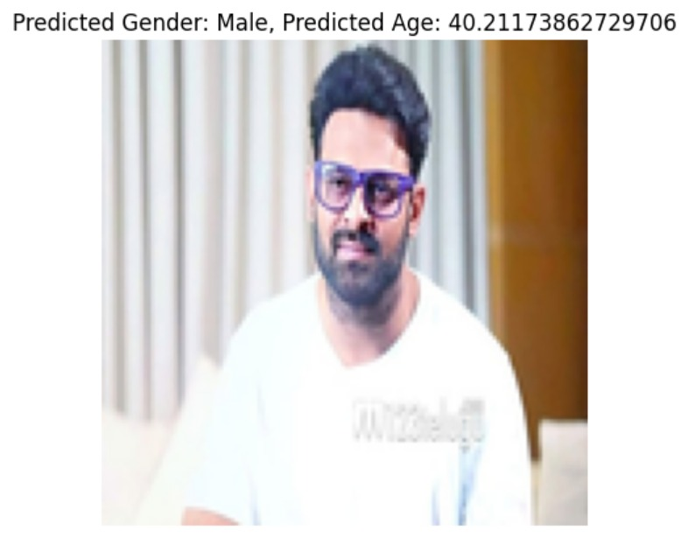

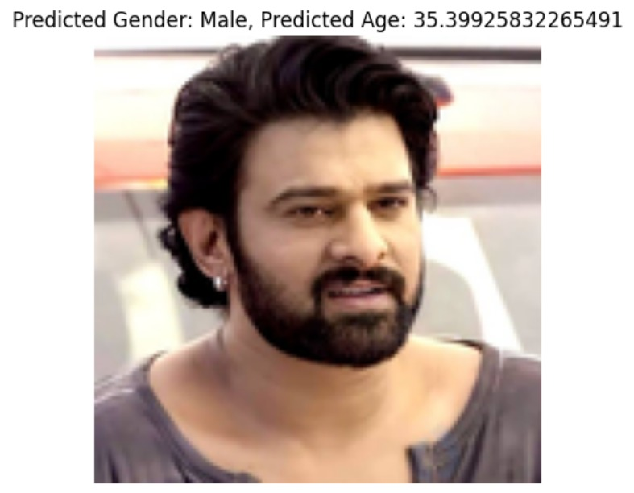

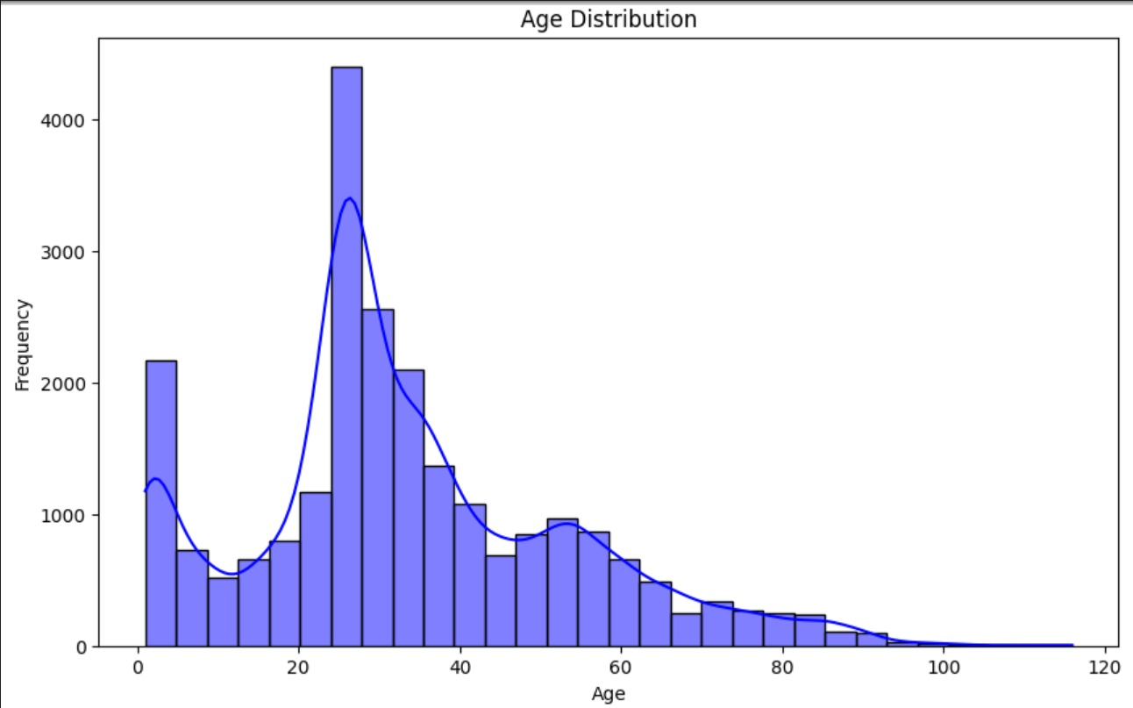

Figure1.Age distribution plot

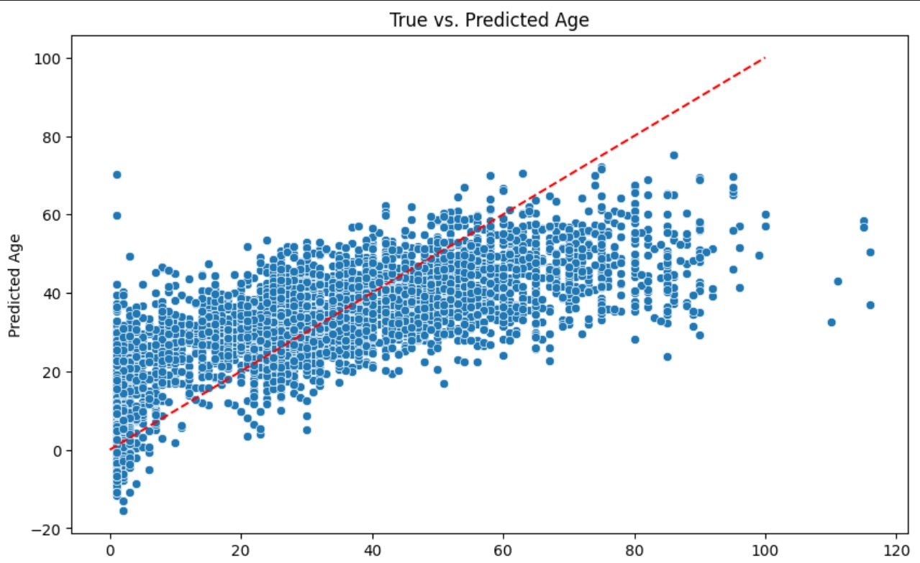

Figure2.Scatter plot for true vs predicted age

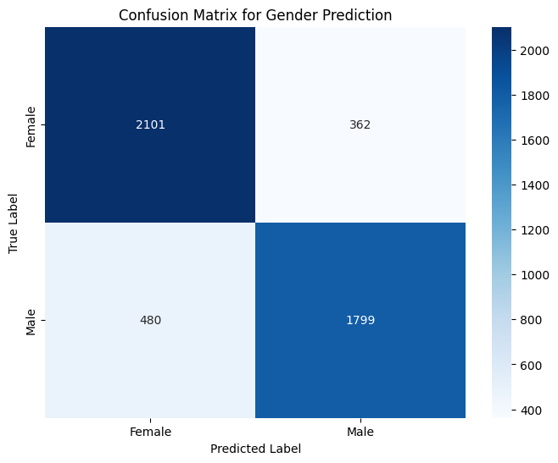

Figure 3 .Confusion Matrix

**For CNN Model :**

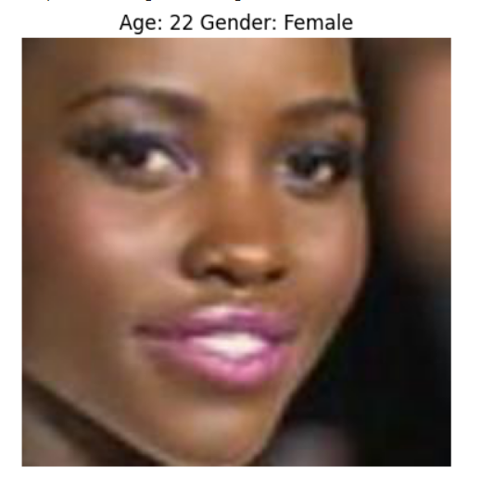

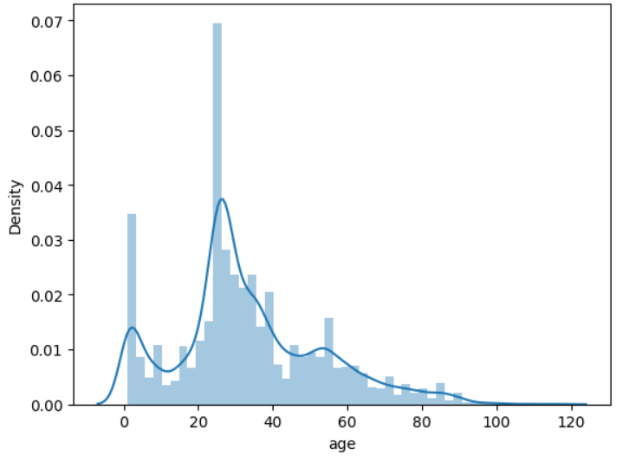

Figure 4.Distribution plot of ages

The distribution roughly follows a normal distribution that is slightly skewed to the right with a median of around 27 years. The range is from 0 to 120 years. There are some outliers at the higher end of the distribution.

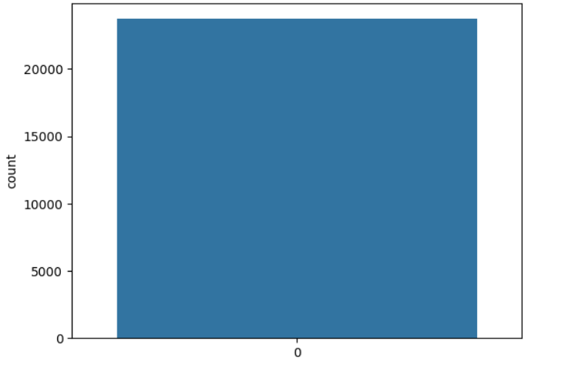

Figure 5.Count plot for gender

The number of samples for females are slightly higher than that of males. However, the dataset is not highly imbalanced.

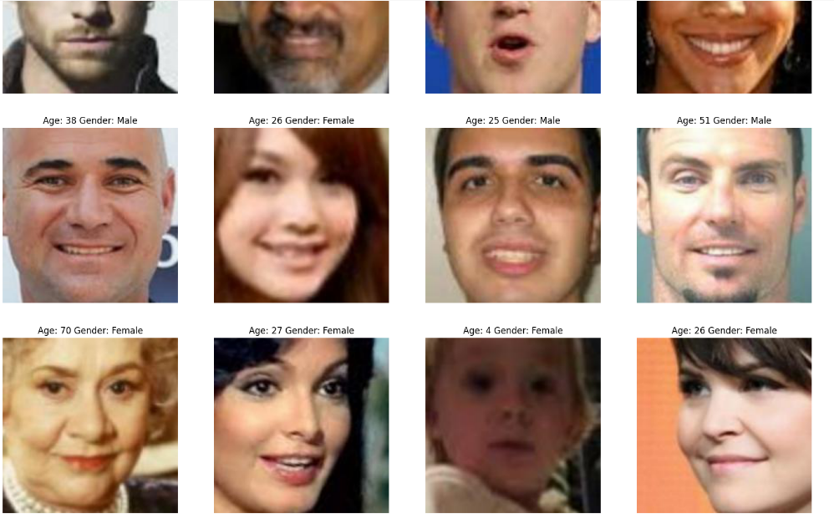

Figure 6 .Grid representation of images

A grid of sample images along with their corresponding age and gender labels is displayed. This provides a visual representation of the dataset and its diversity.

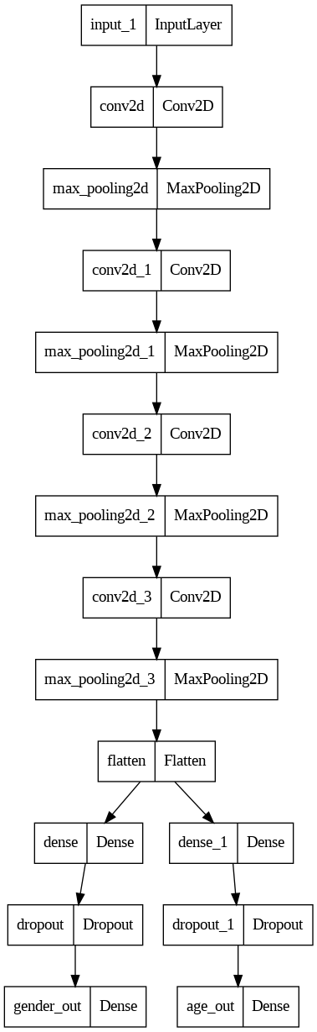

Figure 7 .CNN Model Architecture

**For Gender :**

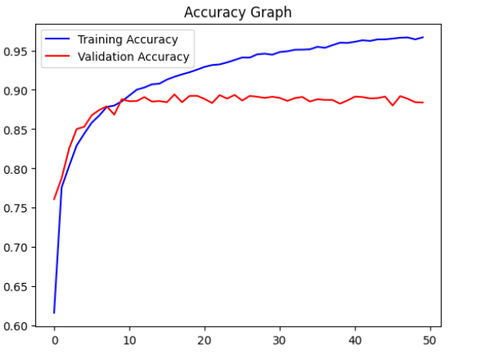

Figure 8.Accuracy graph

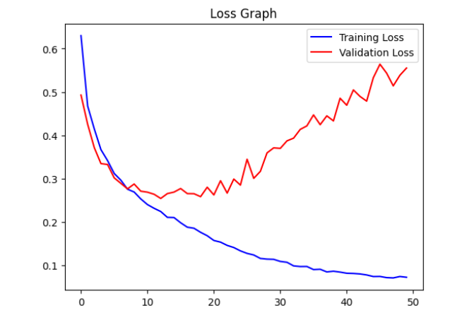

Figure 9 .Loss graph

**For Age :**

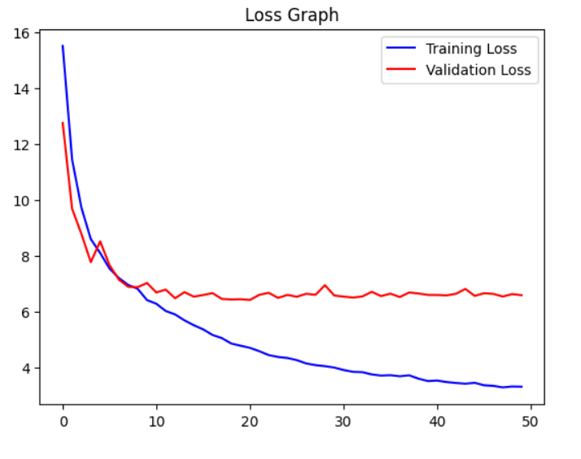

Figure 10.Loss graph

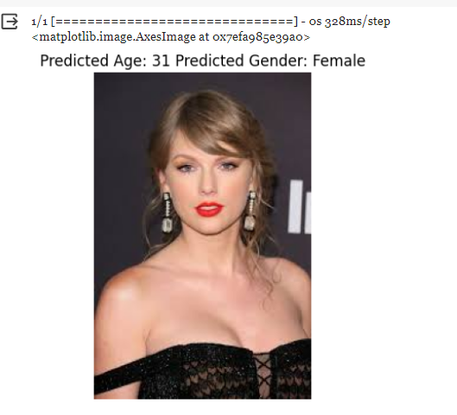

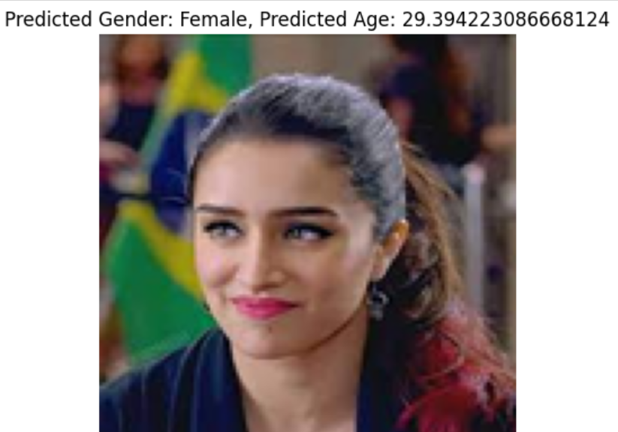

# Future Work and Scope

# In contemporary society, the integration of machine learning algorithms has revolutionized the landscape of age and gender recognition systems. These systems, employing sophisticated facial analysis techniques, hold significant promise across a multitude of domains, ranging from retail and security to healthcare and social media. Their deployment in various sectors underscores the transformative potential of AI-driven technologies in shaping our daily experiences and interactions.

# In retail environments, the application of age and gender recognition technology transcends conventional marketing strategies by enabling personalized product recommendations and immersive customer experiences. By harnessing demographic insights, retailers can tailor their marketing campaigns, optimize store layouts, and curate product assortments to resonate with the preferences of diverse consumer segments. This level of customization not only enhances consumer engagement but also fosters brand loyalty and drives revenue growth in an increasingly competitive market landscape.

# Similarly, in the realm of security and surveillance, age and gender recognition systems offer unprecedented capabilities for crowd analysis, anomaly detection, and threat mitigation. Deployed in public spaces such as airports, train stations, and city centers, these systems enable proactive monitoring, rapid response, and enhanced situational awareness. By leveraging real-time data analytics and predictive modeling, security personnel can identify potential risks, deter criminal activities, and ensure the safety and security of citizens in densely populated areas.

# Moreover, the integration of age and gender recognition technology in healthcare settings has profound implications for patient care, treatment planning, and medical diagnostics. Healthcare professionals can harness demographic data to personalize treatment regimens, optimize medication dosages, and monitor disease progression with greater precision and accuracy. Furthermore, age and gender recognition systems facilitate the early detection of age-related health conditions, thereby enabling timely interventions and preventive measures to mitigate long-term health risks and improve patient outcomes.

# In the realm of social media and digital advertising, age and gender recognition technology serve as invaluable tools for content targeting, audience segmentation, and campaign optimization. By analyzing user demographics and behavioral patterns, advertisers can deliver highly relevant and personalized content to their target audiences, thereby maximizing engagement, conversion rates, and return on investment. This data-driven approach not only enhances the effectiveness of advertising campaigns but also fosters a more immersive and personalized user experience on digital platforms.

# Additionally, age and gender recognition technology have far-reaching implications for market research, audience analysis, education, and public policy. Media organizations and market researchers can leverage demographic insights to gain a deeper understanding of audience preferences, content consumption habits, and market trends. Educational institutions can utilize age and gender recognition systems to customize learning experiences, adapt teaching methodologies, and promote student engagement and academic success. Moreover, government agencies can leverage demographic data to inform policy decisions, allocate resources, and address socio-economic disparities across various demographic groups.

# Looking ahead, future research in age and gender recognition technology should prioritize several key areas, including improving model accuracy and robustness, enhancing privacy-preserving techniques, advancing age progression and regression analysis, enabling real-time and resource-efficient deployment, and promoting ethical and responsible AI practices. By addressing these research challenges and exploring new avenues for innovation, we can unlock the full potential of age and gender recognition technology to drive positive societal impact and empower individuals across diverse domains.

# Conclusion

In this research paper, we embarked on a comprehensive exploration of age and gender detection utilizing machine learning methodologies, with a particular focus on convolutional neural networks (CNNs). Our study aimed to elucidate the efficacy of CNN-based approaches, scrutinize model performance across benchmark datasets, and delve into the ramifications of age and gender detection in practical settings.

Through meticulous experimentation, we substantiated that CNNs exhibit superior performance compared to traditional machine learning algorithms in age and gender prediction tasks. Our empirical analyses underscored the heightened accuracy and robustness of CNN-based models, especially when trained on expansive and diverse datasets. Notably, our comparative assessments of various CNN architectures unveiled nuances in performance metrics, emphasizing the criticality of selecting tailored architectures for specific applications.

Moreover, we delved into the ramifications of preprocessing methodologies, hyperparameter tuning, and ensemble techniques on model efficacy. Our findings underscored the pivotal role of meticulous preprocessing and hyperparameter optimization in enhancing model convergence and prediction precision. Additionally, ensemble methods emerged as potent tools for harnessing the diversity of model predictions, thereby amplifying overall performance metrics.

Ethical considerations loomed prominently throughout our study, as we conscientiously addressed algorithmic fairness, privacy imperatives, and biases inherent in demographic inference systems. We emphasized the imperative of fostering transparency, accountability, and mitigation strategies to contend with unintended ramifications in the responsible deployment of age and gender detection technologies.

Looking towards the horizon, we delineated several avenues for future research in age and gender detection leveraging machine learning paradigms. Envisaged advancements in CNN architectures, exploration of multimodal data fusion, and the quest for interpretable models stand as promising trajectories. Concurrently, mitigating challenges such as dataset biases, model interpretability, and equity concerns in demographic inference systems remains paramount.

In conclusion, our research endeavors contribute substantively to the burgeoning discourse surrounding age and gender detection, underscoring the prowess of CNN-based methodologies for precise and reliable demographic inference. By elucidating methodological intricacies and advocating for ethical imperatives, we strive to chart a course towards the judicious development and deployment of age and gender detection technologies across diverse domains.

10. References

1. ElKarazle, K., Raman, V., & Then, P. (2022). Facial Age Estimation Using Machine Learning Techniques.
2. Khan, B., & Khan, S. (2023). Author's Age and Gender Prediction on Hotel Review Using Machine Learning Techniques.
3. Carletti, V., Greco, A. S., Percannella, G., Vento, M., & Fellow, I. (2013). Age estimation from face images.
4. Gao, B. B., Zhou, H. Y., Wu, J., & Geng, X. (2018). Age estimation using expectation of label distribution learning.
5. Levi, G., & Hassner, T. (2015). Age and gender classification using convolutional neural networks.

1. Eidinger, E., Enbar, R., & Hassner, T. (2014). Age and gender estimation of unfiltered faces.
2. Gao, F., & Ai, H. (2009). Face age classification on consumer images with Gabor feature and fuzzy LDA method.
3. Guo, Y., & Wang, Y. (2022). Age and Gender Recognition from Face Images Based on Deep Learning.

1. Zhang, X., & Li, Y. (2022). Age and Gender Classification from Face Images Using Deep Learning
2. Zhang, X., & Li, Y. (2022). Age and Gender Classification from Face Images Using Convolutional Neural Networks.